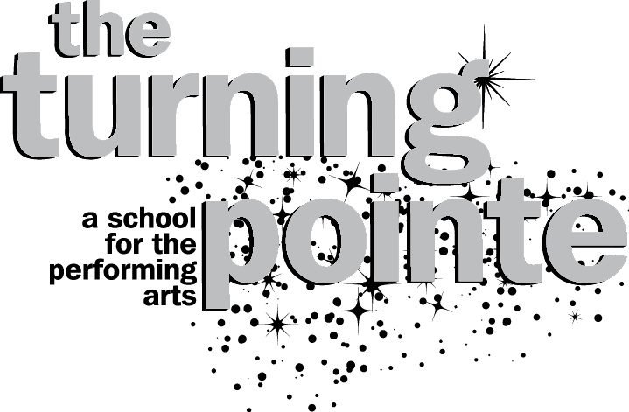

**Shoe Requirements and Dress Code**

**for the 2025/2026 Dance Season**

**\*\*\* Please make sure your name is on all of your shoes and dancewear \*\*\***

**We Recommend that all Dance Shoes be tried on and are worn to fit now and not months from now. Ballet & Jazz Shoes need to fit like a glove!**

*** All Dance shoes & Dance attire may be purchased at Fancy Dancers ***

23517 Nine Mack Drive, St. Clair Shores, MI 48080 - # (586) 775-4167

Ballet Shoes - **\*\* You MUST buy shoes very snug to fit like a glove! \*\***

Youth (ages 3 to 12) – Pink Bloch Basic Ballet Shoe, Style # 249

Teens/Adults & Comp Dancers – Pink Capezio Hanami Canvas or Leather Split Sole Shoe, Style # 2037

Tap Shoes -

Youth (ages 3 to 12 aprox.) – Bloch Tan “Merry Jane” Tap Shoes, Style #SO352

Teens/Adults (12 & up, Level III & UP ) – Bloch Black Jazz/Tap Oxford, Style #SO301

Jazz Shoes - **\*\* You MUST buy shoes very snug to fit like a glove! \*\***

Pre Jazz I Classes (age 4 to 6) – Plain White Canvas Tennis Shoes

All Dancers age 7 & up – Bloch “Pulse” Jazz Shoe, color Blk or Tan, Style # 470

Lyrical Shoes - **\*\* You MUST buy shoes very snug to fit like a glove! \*\***

All Classes – Nude Capezio Leather Pirouette II, Style # H062 ($27)

Hip Hop Shoes -

All Classes – Tennis shoes that are bought & ONLY worn for dance class! No outside shoes!

Ballet Attire =

You must be dressed in a black or pink leotard and pink dance tights. Hair needs to be in a bun, away from your face and off your neck. No bras or other undergarments that can be seen are allowed! No sports bras under your leotards if they can be seen! Buy leotards that support you or hide your bras and straps! You should never wear ripped or torn tights to class! No shorts allowed over your leotard in ballet class at any time! Also, dancers may not wear any jewelry with the exception of small, stud earrings.

**Boys – Solid Color Dance pants with a white or black tailored tank or t-shirt, black ballet shoes**

Side note…Pointe shoes may only be purchased upon the instructor’s recommendation. A student must be ready, and proper weight management is essential before approval for participation. Students and parents will be given specific guidelines once evaluation has been completed.

Tap, Jazz, and Lyrical/Contemporary Attire =

All dancers must be dressed in a leotard and tights or an appropriate dance top/sports bra with dance shorts/leggings and tights! There are no restrictions on color or style for these classes, however you must be dressed in dancewear, NOT gym or beachwear! No baggy or loose fitting clothes allowed! And no jewelry! Also, please remember that dance tights are designed and manufactured for dance class and are intended to be worn without underwear. Please do not wear nylon stockings or fashion tights in place of dance tights.

Hip Hop Attire =

Dancers must wear some type of dance or exercise apparel – examples include a leotard with tank top and sweatpants over it, or leggings with a sports bra and tank top. Absolutely no jeans!!! Remember …if you wore it to school, you cannot wear it to dance! Even though hip hop dancers are not required to always wear a leotard and tights, you still need to wear something that is specifically designed for dance! Have fun creating your own unique hip hop style!

Acrobatic Arts Attire =

All dancers must wear a leotard, biketard, or unitard. NO tights (except for convertibles that aren’t covering your feet) and NO shoes. Hair must be bulled back neatly off your face in a LOW ponytail or bun.

You must be dressed appropriately in order to take class and be successful! Looking and feeling like a dancer is critical to the learning process! Being improperly dressed is considered disrespectful to the teacher and the class, and therefore will be grounds for being asked to sit out! This includes not only having proper shoes and proper dance clothes, but also proper hair styles! All hair must be pulled back, neat and clean, and completely off your face. Hair must stay put for the entire class. Use barrettes, hair nets, bobby pins, lots of gel, and hair spray. In addition, for our middle school and high school age dancers, we highly recommend refraining from wearing glasses in class if possible.

**Remember that your appearance goes a long way in defining you as a dancer!**